YOUR NAME: _____________________________________________________

IMPORTANT NOTE: Please only do this at the end of Session 4.
We have written examples for our product idea, Paracord People keyrings, to help you understand what you need to write about your product.

1. DESCRIBE YOUR PRODUCT HERE:
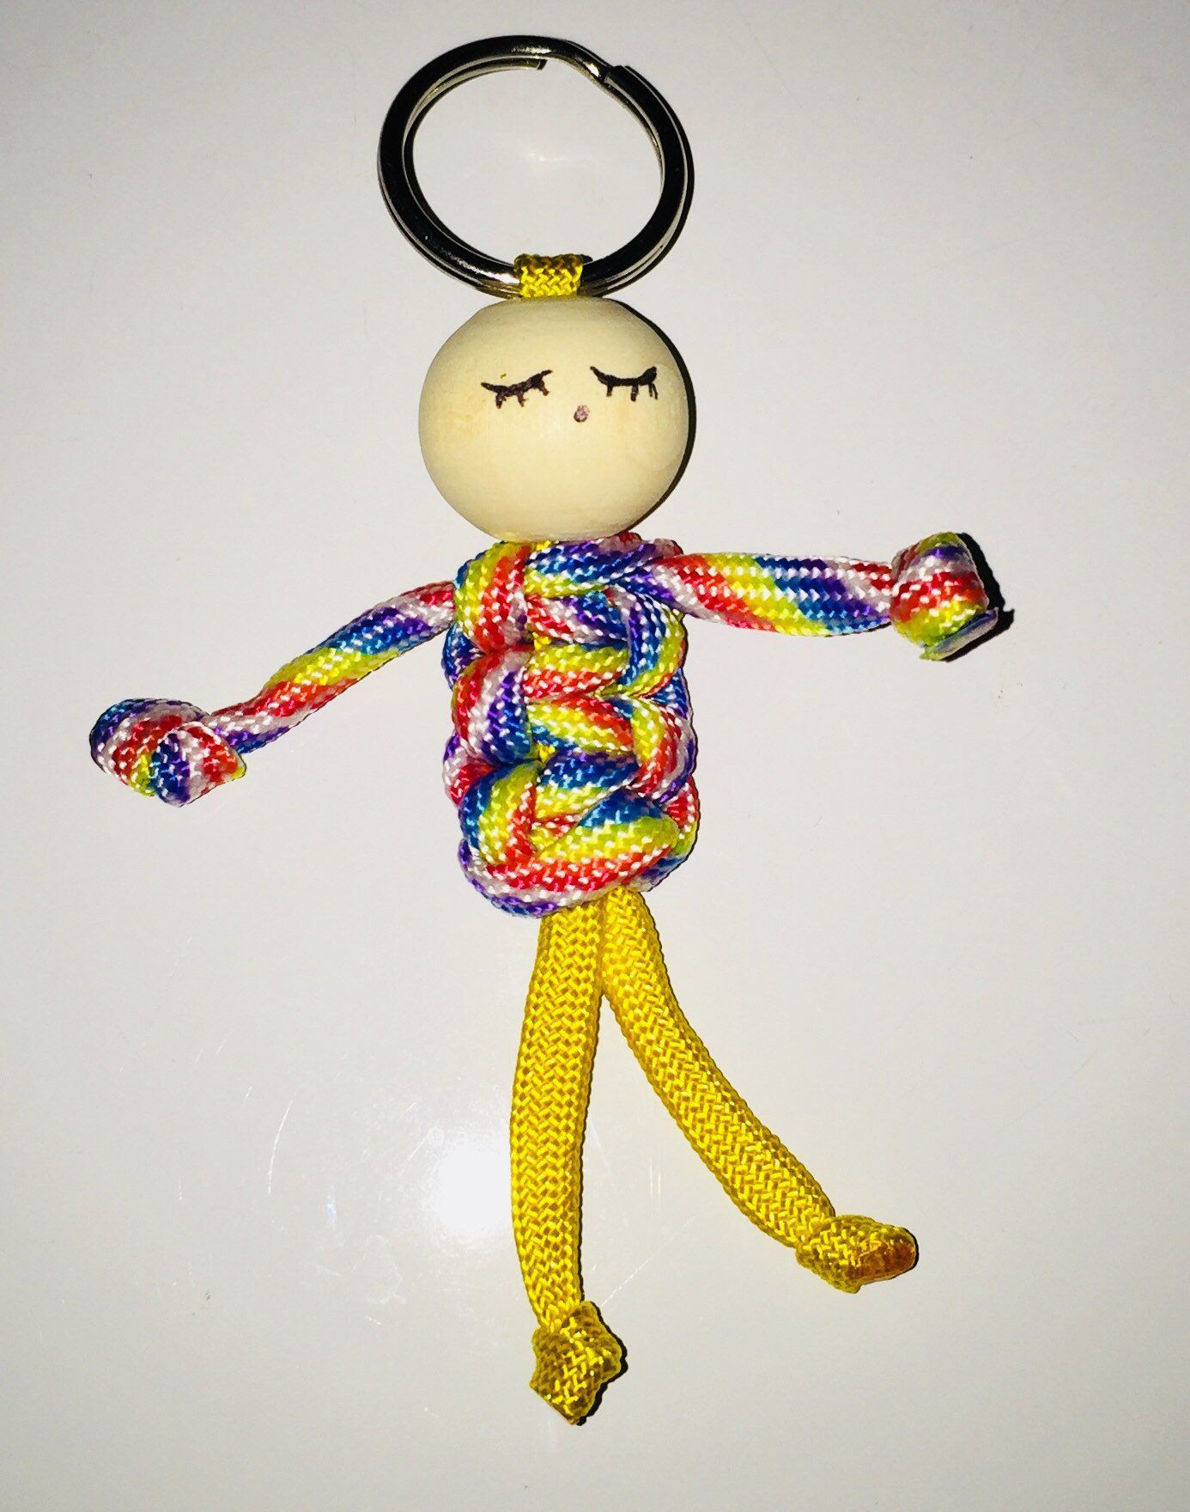
Choose ONE product and describe it here. Remember, it’s a good idea to start small while you test out your product. Make sure your idea is not too expensive. You can include a picture here.
For example: My product is Paracord People Keyrings made using paracord and wooden beads. This is a picture of what they will look like.

2. EXPLAIN HOW YOU MEET THE 3 GOLDEN RULES OF PRODUCT DEVELOPMENT HERE:

Which customer need will your product satisfy?
For example, “my Paracord People keyrings will satisfy two needs - they help customers easily identify their own keys (especially in families where everyone has their own key) and also tap into the craze for younger people to decorate their bags with fun objects.”

How does your product add value?
For example, “I will add value by buying low cost raw materials and using my skill and time to make paracord keyrings by hand.”

How will your product stand out from your competition?
For example, “my keyrings are handmade and each one will be unique in colour and design. I will also create a strong brand to make them stand out.”

