YOUR NAME: _____________________________________________________

IMPORTANT NOTE: Please only do this at the end of Session 13.

Come up with an advertising Campaign for your product

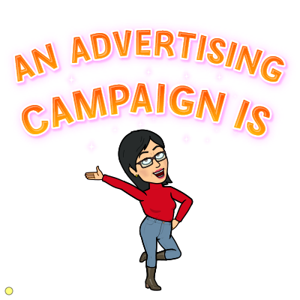
a series of promotional messages that share a single idea and theme to create awareness of your brand and product
and to increase sales.

To be successful, your advertising campaign should:
- be memorable (will they remember it?)
- be meaningful (will customers feel that the adverts relate to them personally?)
- make customers feel better or happier (will customers feel they benefit from the product?)
- be clearly linked to your brand (will customers know the ad is for your product not a competitor’s?)
- stand for positive values? (does the ad send out a positive message about your business?)

My IDEA for the advertising campaign for my product is:
- e.g. Marmite’s idea was “to use hypnosis to turn Marmite Haters into Marmite Lovers”

The THEME for the advertising campaign for my product is:
- e.g. Marmite used “hypnotic” images in all their ads. Make sure you use your Branding Worksheet so that you show things like your logo colours and your slogan in your promotion message.

The TYPES OF ADVERTISING I will use in my advertising campaign are:
Adverts in newspapers, magazines and on television are very expensive. For your mini business, you will need to keep your advertising expenses low. We suggest you use a combination of the ideas listed below.
Tick the types of advertising that you would like to use. You won’t need to do all of them. Later, you will pick one that you will create.
- A flyer that can be sent out to customers – either a printed version or via email or messaging.
- An online poster that can be shared on social media (by an adult if you are not old enough to do this).
- A blipvert (a video lasting a few seconds - remember Marmite’s Squirrel blipvert?) that you try to make go viral.
- An interview on local radio that you get by writing a convincing letter about why your idea is newsworthy.

Design your adverts for your campaign

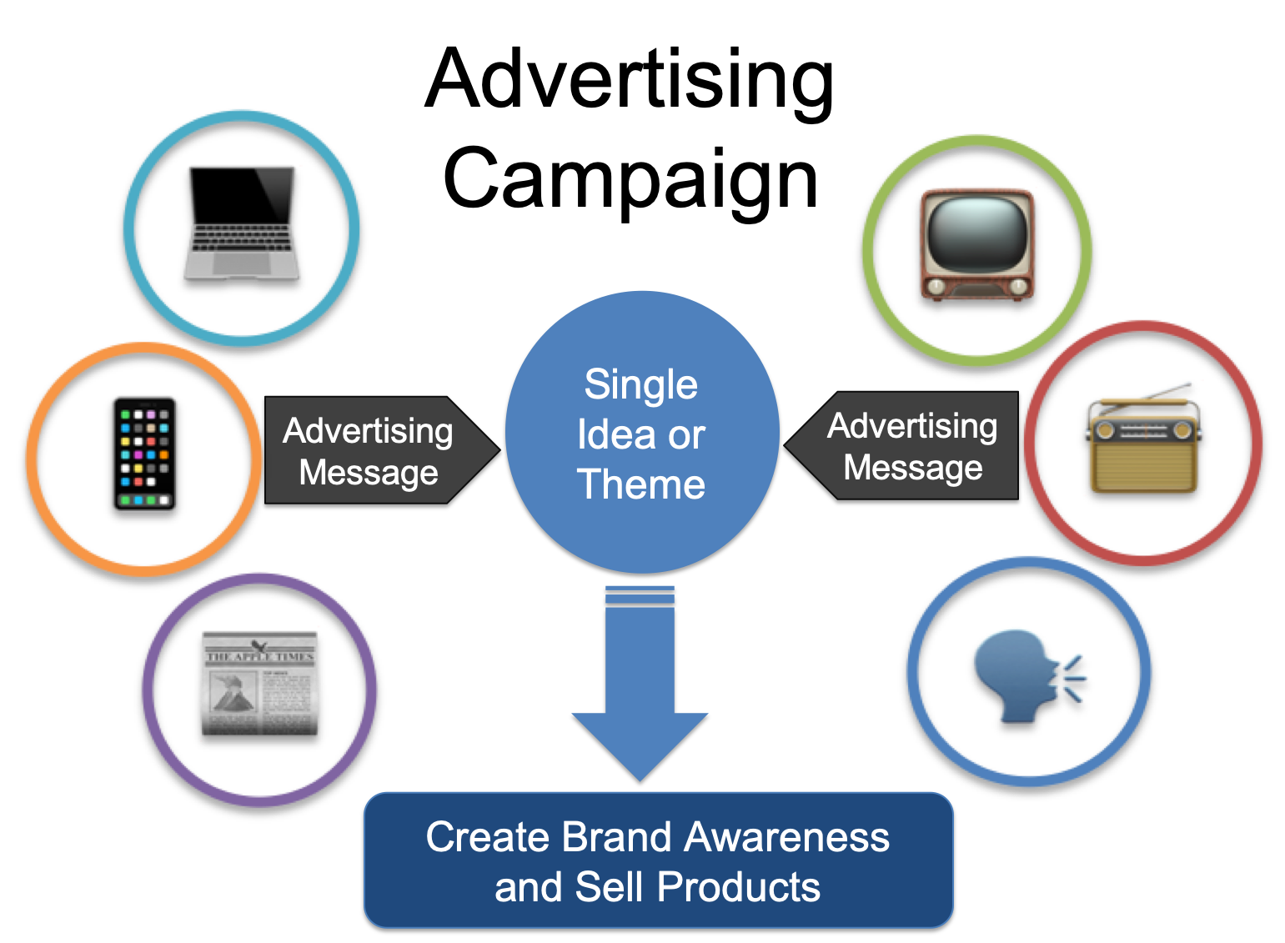
Choose one (or more) of the advertising types (flyer, radio, blipvert, online poster, etc.) that you will use in your campaign and start designing it in this space.

You might like to use a particular skill you have to decide:
- if you enjoy art or computer design, choose a flyer or online poster.
- If you enjoy drama and being in front of the camera you could try a blipvert.
- If English or public speaking is your strength, why not write a letter that you could send to a local radio station?

Remember, your ad campaign ould be memorable, meaningful, make customers feel better or happier, be clearly linked to your brand and stand for positive values?

The advertising type that I will design below is: ________________________________________________

